Blended Learning Professional Development
Rachelle Wooten
Lamar University

Blended Learning Professional Development
Blended learning is a trending instructional model in K-12 schools today (Johnson, 2015). By combining the best practices in traditional face-to-face instruction with the anytime, anywhere access of online instructional content this emerging model is opening the door to a more personalized, differentiated approach to reaching a diverse group of learners (Johnson, 2015). This new approach allows students to move at their own pace, and get the much needed support from their teachers and collaboration with their peers (Johnson, 2015). This model has not only meant a change in the role of the student but also a shift in the role of the teacher (Johnson, 2015). With such a modification in the teacher’s role there will need to be a shift in how teachers are prepared for blended learning instruction (TNTP, 2014). This paper will explore the significance of quality professional development, what blended learning professional development looks like, and an analysis of the role of blended learning instructor.
Much of the literature emphasizes the importance of quality professional development when preparing teachers for blended learning instruction. Actually, Nadia Pierce who is vice president of iReady for Curriculum Associates says the best blended learning implementations are the ones where the district has made time for training teachers on the platform and how to analyze the data in such a way as to drive instruction (Fagnani, 2014). Tom Vander Ark, CEO of Getting Smart an education firm that focuses on innovation and technology says that successful blended learning rollouts share five basic strategies and one of those is choosing appropriate staffing and professional development. (Paulson, 2014) Andy Calkins, deputy director of Next Generation Learning Challenges, another organization that helps districts and chartered schools plan their blended learning programs say the key to doing it well demands thoughtful planning and more time spent on finding a solution to issues like student schedules, class makeup, teacher training, and classroom management and not a lot of time on choosing hardware and software. (Paulson, 2014) These are the suggestions of outside consultants but the same is said of actually school leadership that have piloted and implemented blended learning instruction on their campuses. For example, research from the state of Ohio surveyed a variety of school leaders out of the many chartered schools and districts that are already implementing blended learning and the responses echoed in their results. In fact, one of the greatest needs of respondents was a desire for more “high quality” professional development. About 36% of respondents said finding high-quality professional development was difficult and 28% wished they could have provided more professional development before implementing their blended learning programs. Professional development plays such a critical part in helping teachers to be effective as blended learning instructors. Even more so since most teachers were not introduced, let alone prepared, for blended learning in their preservice programs and teacher training. One respondent put it this way, “Professional development is our biggest need. Finding tie and resources for that professional development are the biggest issues.” (Arnett, 2015) Most of the comments were connected to the professional development of teachers and not leaders. Interestingly, only a third of the responded even provided some kind of blended learning professional development for their school or district leadership. When professional development was provided, it was general and not specific to blended learning. (Arnett, 2015) It is clear from many different roles in blended learning support that high-quality professional development must be a priority for a successful implementation. However, the research does not clearly define what high-quality is or what it looks like. If high-quality is what is required, then it is crucial that it be defined and outlined clearly so that professional development providers, consultants, and universities can prepare teachers for this new role.
The need for quality professional development for blended learning instructors could be significant because the responsibility and function of a blended learning instructor is different than that of a traditional teacher. This new role actually builds upon the foundation of solid great traditional instruction. According to a report by the International Association for K-12 Online Learning (iNACOL) the major difference between the two is the pace of technological change, the need for teachers to incorporate more novel approaches, and the prospect of truly differentiating to the many learning styles of their students. (Powell, 2014) The organization also makes some key assumptions about the competencies for blended learning teachers. They are said to have high expectations and an obligation to help all students achieve their learning outcomes, they want to move towards mastery not just passing, and they respect all learners and value the different skills, strengths, and needs. The organization has even categorized some blended learning competencies into four categories: Mindsets, Qualities, Adaptive Skills, and Technical Skills. Each of these categories have core competencies and standards that articulate observable and practical ways to assess and implement. (Powell, 2014) Another report by The New Teacher Project (TNTP) created a visual comparison that outlines the differences between the traditional teacher and the blended learning teacher in Figure 1. Blended Learning Teacher vs. Traditional Teacher Roles. (TNTP, 2014) The organization states that implementing blended learning provides an opportunity to look at the role of the teacher as a continuum with three different functions that could easily be shared among a group of educators. This could be advantageous for educators because traditionally teachers have taught in silos within the school community. In summary what teachers need to know and be able to do looks different, and the way to develop them must also look different. (TNTP, 2014) The research offered a clear picture to distinguish the role of the blended learning teacher and the traditional teacher. It even gave some suggestions for how to recruit, select, and evaluate teachers in this new role. What is still missing is a clear set of guidelines on what kind of professional development is best suited to equip teachers for this evolving role.
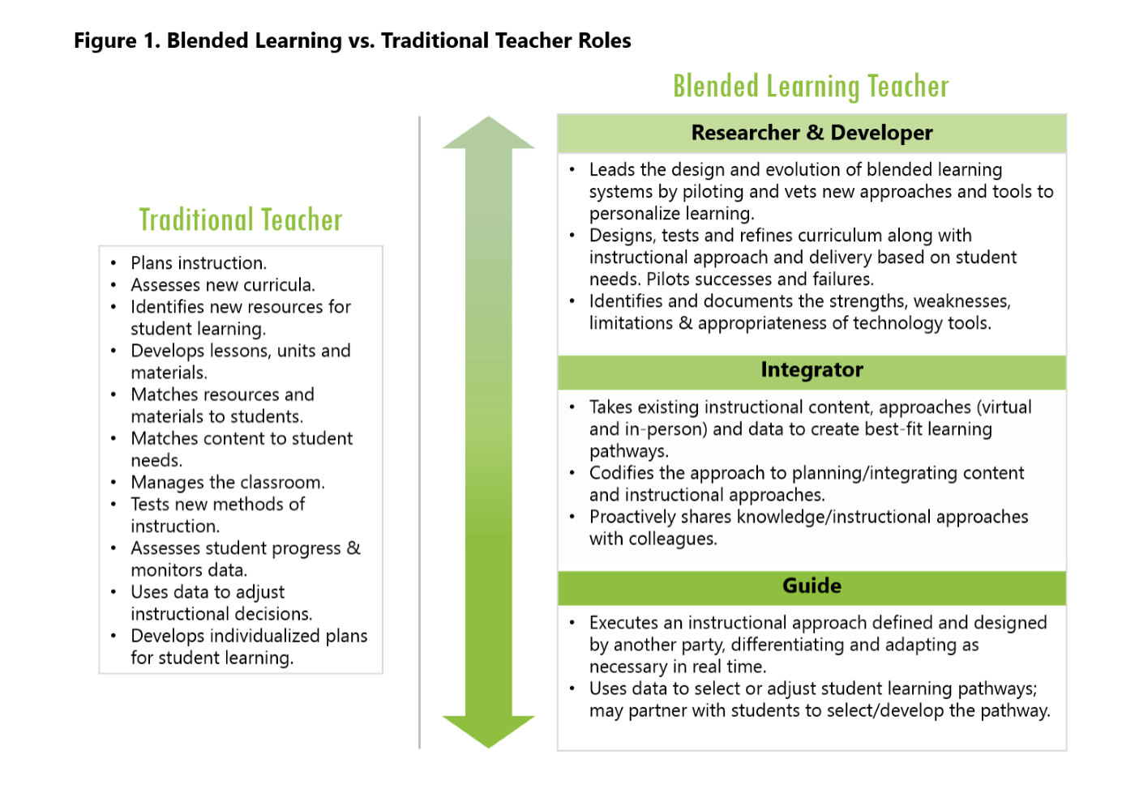
Figure 1. Blended Learning vs. Traditional Teacher Roles
Just as there are different models of blended learning, there are many different approaches for preparing teachers for blended learning instruction. One report by the Ohio Blended Learning Network suggests that teachers and leaders are trained on iterative innovation processes. Iterative innovation processes are systems of action, tools, and engagement that work together so that they can absorb disruption rather than be engulfed by it. (Trigleth, 2014) When schools assimilate an iterative innovation process they can move more quickly and efficiently to meet their desired outcomes. (TNTP, 2014) Once there is a process in place, the focus must turn to helping teachers modify their existing lessons to one that is suitable for blended learning instruction. At Canyon Ridge High School, they accomplish this by having teachers start with their “golden nugget” lesson – those lessons that they believe were most effective and engaging with their students. This helps them to shift to this new instructional model with less stress and at their own level. (Kleber, 2015) Because teachers, like students, will come with varied skill levels and confidence to the professional learning environment this is an opportunity for leadership to model the mindset that makes blended learning so effective. For example, help them keep the focus on what the students need to learn and know, embrace mistakes, move at your own pace, provide support and encouragement, and finally remember that teamwork is critical. (Kleber, 2015) Some innovative teacher education programs have already begun integrating blended learning. One such program, the Relay Graduate School of Education, offers a Master of Arts in Teaching where 40% of the instruction is delivered online and the other 60% is delivered face-to-face. The competencies are offered in modules that teachers can either pass over or review based on their level of mastery. It also includes an online video library where they watch videos that model best practices in real classrooms. Relay has been recognized as an exemplar for an affordable teacher education program that can be duplicated by others. (Johnson, 2015) The research suggested some necessary processes that should be included in blended learning professional development. The practical ideas suggested ways to make the teachers transition less overwhelming. While there was a mention of the innovative work of Relay Graduate School of Education there is no clear picture of how this blended learning model could look in K-12 schools. This would be an area where further research would be beneficial as a district seeks to prepare their teachers for blended learning instruction.
In conclusion, the blended learning instructional model is one that shows promise for differentiating instruction, personalizing learning, and increasing. However, even in its infancy in most schools the issue of quality professional development is a challenge. This could be because the shift in the role of the teacher is different under this approach. Just like there are different models of blended learning, there are myriad approaches to preparing teachers for this role. Universities, K-12 schools, and professional development providers must consider what is the most effective ways to prepare teachers to be effective in this new role.

References
Arnett, T., Benson, B., Bridges, B., Bushko, K., Duty, L., Mohammed, S., (2015) State of Opportunity: The Status and Direction of Blended Learning in Ohio. http://learningaccelerator.org/media/abc5d315/Ohio%20Report%20101415_F.pdf
Fagnani, S. (2014) Rolling Out Blended Learning. District CIO. www.districtadministration.com
Johnson, L., Adams Becker, S., Estrada, V., and Freeman, A. (2015). NMC Horizon Report: 2015. K-12 Edition. Austin, Texas: The New Media Consortium
Kleber, J. (January/February 2015) “Differentiation Through Blended Learning”. Leadership.
Paulson, A. (2014) Blended Learning Revolution: Tech Meets Tradition in the Classroom. Christian Science Monitor. http://www.csmonitor.com/USA/Education/2014/0420/Blended-learning-revolution-Tech-meets-tradition-in-the-classroom.
Powell, A., Rabbitt, B., Kennedy, K. (2014) iNACOL Blended Learning Teacher Competency Framework. http://www.inacol.org/resource/inacol-blended-learning-teacher-competency-framework/.
Reimagining Teaching in a Blended Classroom. (2014) The New Teacher Project (TNTP). http://tntp.org/assets/documents/TNTP_Blended_Learning_WorkingPaper_2014.pdf
Trigleth, W. (2014) Iterative Innovation. Cannon Financial Institute. https://www.cannonfinancial.com/article/iterative-innovation

