Rachelle Wooten
EDLD 5304 Lamar university
influencer strategy

Influencer Strategy
Rachelle Wooten
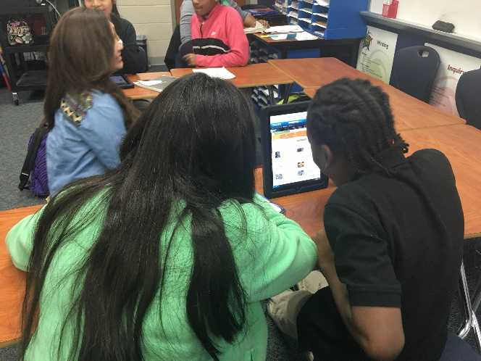
In Fort Bend ISD, we have purchased Edgenuity Learning Management System as a tool to help many of our students recover credit for courses they need to complete in order to graduate. We have even arranged and structured some of the courses to meet the pacing and standards of our district curriculum. In fact, some of their standards have been addressed and designed as blended learning modules in In order to assist our English I teachers in moving towards creating blended learning environments, it will be beneficial to have them begin using this tool that we already have to help them supplement their instruction in order to best meet the needs of their students.
Students working together in groups.

Goal:
Increase the use of Edgenuity as a blended learning tool with our English I classes to positively address gaps in student learning by May 2017.

Desired Results

Desired Results | How we will measure?
Increase the use of Edgenuity in English I courses | - Edgenuity usage reports  - Edgenuity user group reports
Identify weaknesses in student learning in English I courses and positively address them | - Pre-assessments given before instruction and Edgenuity lessons  - Edgenuity student progress reports  - Student work
Develop a deeper understanding of a blended learning instructional model as a way to meet needs of different learners | - PLC meeting notes and agenda  - Professional learning evaluations  - Teacher artifacts and evidence  - Classroom Observation  - Student survey  - Teacher survey

We will consider the following factors when choosing our vital behaviors:
Notice the obvious
  - All students and teachers have accounts to Edgenuity but not all students and teachers are using Edgenuity.
  - Some teachers at some campuses have not been trained on Edgenuity as a blended learning tool.
  - Many of our core content area teachers are currently not using Edgenuity because they view it only as credit recovery.
  - Teachers who are using the tool for more than one way are showing greater results academically.

Look for crucial moments
  - If left to do this task on their own teachers may or may not do it. So it is probably best to have them assign these lessons when they are already meeting in their English I teams.
  - Teachers need to use the data to address the gaps in student learning and make changes or modifications to their lessons.
  - Teachers need to build in accountability expectations for students performing lower than X on content standards.

Learn from positive deviants
  - Teachers that are using Edgenuity as a blended learning tool to supplement instruction are seeing great gains academically.
  - Teachers have analyzed the student data to make changes in their face to face class time.

Spot culture busters
  - Some teachers (and students) may only think of Edgenuity as the tool that our students are using for credit recovery and so they may see this as a remediation tool as opposed to one that can also be used for blended learning.
  - Teachers often see integrating a new technology tool in their learning environments is “adding one more thing” on their plate.
  - English teachers are used to providing lecture and discussions in class and may see this as a tool that will not address students ELA skills.

Vital Behaviors

- Choose at least four standards where students score the lowest in the English I course and set a team goal for where you would like students to be.
- Conduct a pre-assessment for each of the four standards and assign Edgenuity lesson modules to address those areas of weakness in student learning.
- Conduct a post-assessment for each of the four units to identify the impact it had on student learning and use the students’ overall progress score as a major grade. Then, share your findings with your content area team PLC and/or campus.

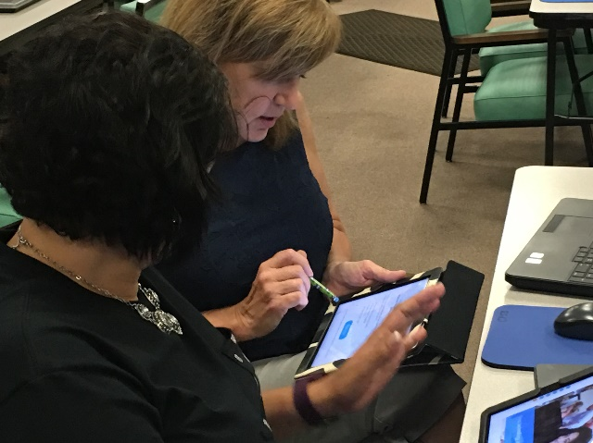
Organizational Influencers

This change will require the support of different departments within the district and at the campus level. Our Curriculum and Instruction is comprised of Curriculum and Digital Learning. We will need educators from both to support teachers, facilitate training, and meet with teachers during their campus professional learning community as they analyze data. We will also need the support of the Campus Assessment Coordinator since they have campus level access to Edgenuity and will be able to run the reports to help us measure this change. Since the Campus Assessment Coordinator is housed on the campuses they are expected to attend the teachers’ professional learning community meetings when they are discussing and analyzing data. The Digital Learning Specialists will facilitate the Edgenuity training for the teachers, help them set up their classes, and provide any ongoing support. Our Helping Teachers will be able to help teachers see the gaps (if any) in student learning and show them some next steps for lesson planning and differentiating instruction.
Teachers learning a new technology tool.

- Susan Voradakis, Director of Secondary Curriculum
- Dr. Heather Pule, Coordinator Secondary ELA, Speech, Debate, and Journalism
- Dawn LaFleur, Helping Teacher ELA
- Jessica Mozisek, Digital Learning Specialist
- Lynette Meyer, Director of Digital Learning
- Rachelle Wooten, Digital Learning Specialist
- Corlette Hill, Secondary Coordinator – Digital Learning
- Chris Freeman, Campus Assessment Coordinator

Negative Influencers

Of course not everyone, will be as ready and willing to adopt this change. So for the negative influencers, it will be important that assess exactly where our staff members are in relation to teaching and in their motivation to participate in this change. For this, we would consider the Will and Skill Matrix to meet them where they are (Jackson, 2008). See Figure 1.1 The Will/Skill Matrix. To reach the negative influencers that are “low skill/low will” we will make sure we have shared the why and how. This is where our vital behaviors will really help us in setting clear expectations (behaviors) for the teachers. Make sure we check in often to monitor progress and hold them accountable to the goal (Jackson, 2008). We will also provide frequent feedback regarding the goal and their progress. This way they may be able to see some “quick wins” and increase their motivation to participate. Then we can provide extra support and training early and often to support them so they cannot say they didn’t know how and they will also have the support of their team to help (Jackson, 2008). The “low will/low skill” teachers may not be the only negative influencers.

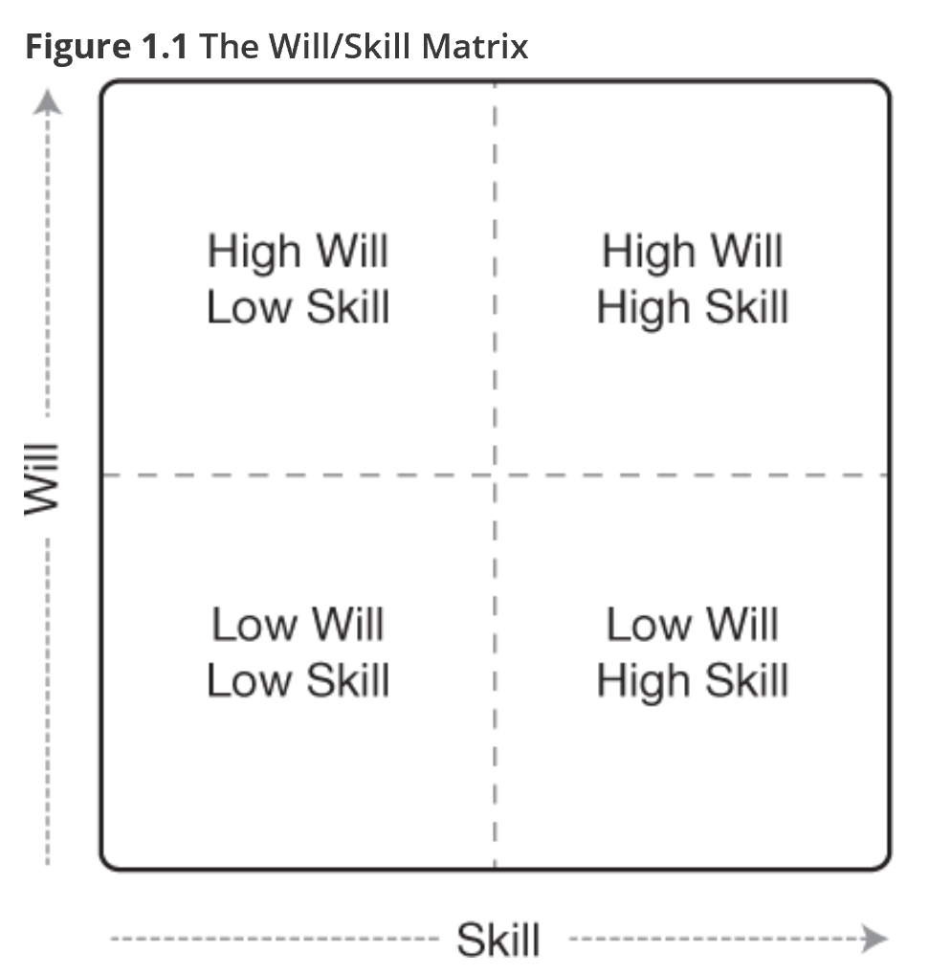

Figure 1.1 The Will/Skill Matrix (Jackson, 2008)
There are also “low will/high skill” teachers that could negatively impact and influence the innovation. For them, we want to make sure they are using the data to track student learning and progress. We will also make sure that the team of teachers have an opportunity to share the in classroom lessons step-by-step with ELA Helping Teacher when necessary (Jackson 2008).

Some of the negative influencers may also come from outside the classroom and at the administrative level. For those, we want to be able to share the why and how. It may be best to consider the “Seven Stages of Concern” model presented in Shirley Hord and Gene E. Hall’s book, Implementing Change. We want to focus on where they are in the chart and move them up the chart by providing the right information. See Table 1 for diagram of Seven Stages of Concern. One of the ways we will meet them where they are is by agreeing on goals for improving student learning. We will make sure we communicate research, exemplars, and our results. We will show how the curriculum and digital learning departments are on board. If the so they can be It is important to share the why and how with them.

Table 1 Seven Stages of Concern (Hall & Hord, 2010)
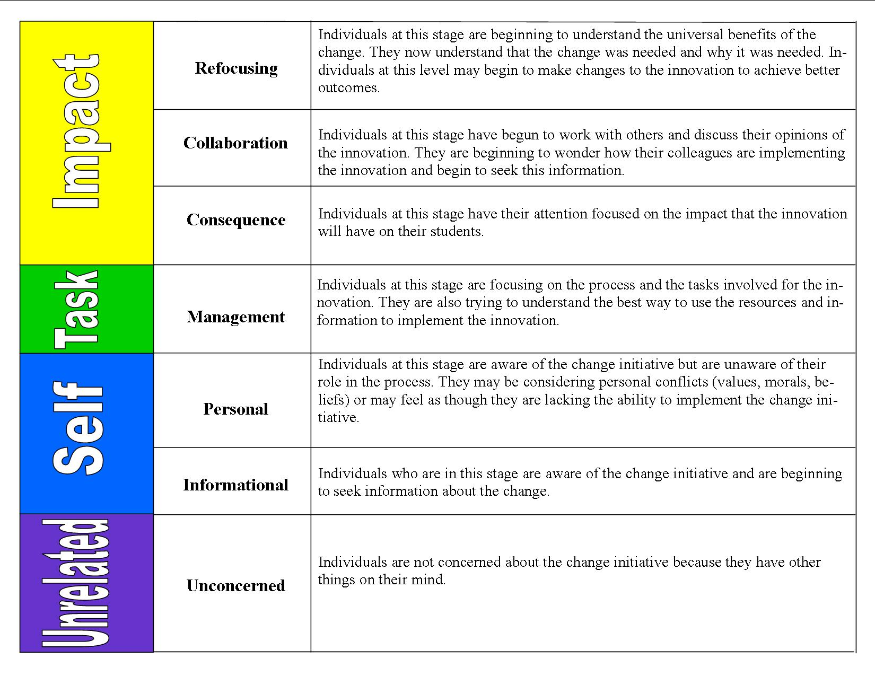

Six Sources of Influence

 | Motivation | Ability
Personal | - Teachers might appreciate that this is instructional content they don’t have to plan/deliver they just need to assign it.  - Teachers may want to learn a new way to teach a novel or literary strategy and the videos may provide a fresh way to liven up an old lesson.  - Teachers will have a choice in how and when students complete lessons – in class or out of class. | - Teachers will be trained on how to use Edgenuity: adding students to groups, assigning lessons, and running reports.  - ELA Helping teachers and Digital Learning Specialists will provide training on collaborative in-class activities and the role of teacher as facilitator since some of the direct instruction might be assigned out of class.  - Campus Assessment Coordinator will provide training on analyzing data and running reports.
Social | - Teachers will be able to make sure they are holding each other accountable for assigning lessons each week.  - Teachers may keep a running record of each ELA teachers’ class progress toward the team “student learning” goal.  - Teachers will meet with other English I teachers across district to share exemplars and best practices. | - Teachers will have a team to work with when it comes to assigning lessons and analyzing student data.  - Teachers will get ideas from other teachers and how they are having students complete the lessons.  - If teachers need ideas for in-class activities the helping teacher and digital learning specialist will help.  - Their Campus Assessment Coordinator will help them when it comes to analyzing the data from the reports in Edgenuity.
Structural | - Special rewards can be given to the winning teachers’ campus who have the highest usage.  - They may be given the opportunity to share their experience during a faculty meeting.  - Teachers may elect to use this as part of an Action Research project where they can also receive a stipend for completing the project.  - For everytime they complete the vital behaviors they get “jeans day” pass.  - Post signs up in hallways and faculty lounge that share tips for using Edgenuity | - Teachers will need to have a common planning period.  - Face-to-face professional learning will be facilitated during the PLC time.  - Administrators will need to provide classroom observations more often and provide feedback to teachers during the blended learning lessons  - Create “pineapple chart” for teachers that are using Edgenuity away from class and doing collaborative learning activities during class time.

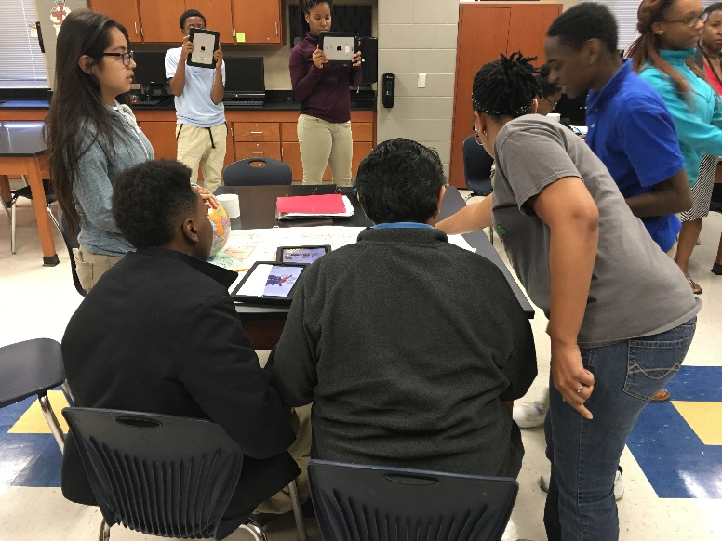

References

Hall, G. E., & Hord, S. M. (2010). Implementing Change: Patterns, Principles, and Potholes. New York, NY: Pearson.
Jackson, R. H. (2008). The Instructional Leader's Guide to Strategic Conversations with Teachers. Washington, D.C.: Mindsteps.

