EDLD 5304 Assignment 1 – What’s Your Why

what’s the why

Assignment 1

why?
In Fort Bend ISD we believe that professional development matters and that it is one of the best ways to positively impact student achievement.

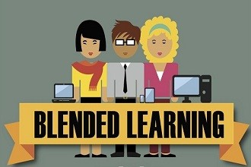
how?
In Fort Bend ISD, we inspire and equip teachers with instructional and professional development support from curriculum helping teachers, digital learning specialists, and teacher development departments that use a blended professional learning model to support teachers and positively impact student achievement.

what?
The Fort Bend ISD Curriculum and Instruction department creates professional learning experiences with a variety of learning designs and research-based best practices that are focused on addressing student learning needs.

background
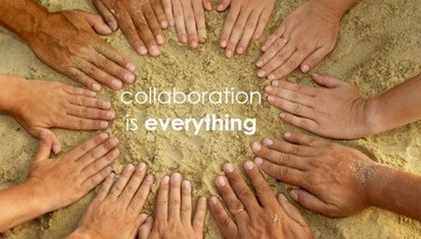
Because the success of most students in a classroom is directly related to the success of their teacher, in the Curriculum Department (Curriculum, Digital Learning, and Teacher Development) we must unite to reach teachers and improve student learning outcomes. At the current time, we facilitate and develop professional development in isolation.

This Spring, our district recently adopted an education technology plan where one of the instructional recommendations was “to adopt a blended learning instructional model”. In my innovation plan, the three departments (Curriculum, Digital Learning, and Teacher Development) collaborate to design a blended professional learning experience that aims to prepare teachers to successfully develop and facilitate blended learning environments of their own.

video reflection:
https://youtu.be/urwhH0X8UIU

image credits:
Blended Learning Picture: http://elearningtags.com/elearning/infographic-how-blended-learning-can-improve-teaching-edtechreview-etr/
Collaboration Picture: http://practicingparadoxy.com/2015/06/14/episcopal-resurrection-rez-4-shared-ministry-collaboration-between-dioceses/
Compassion tree Picture: http://pablodelarosa.blogspot.com.es/

